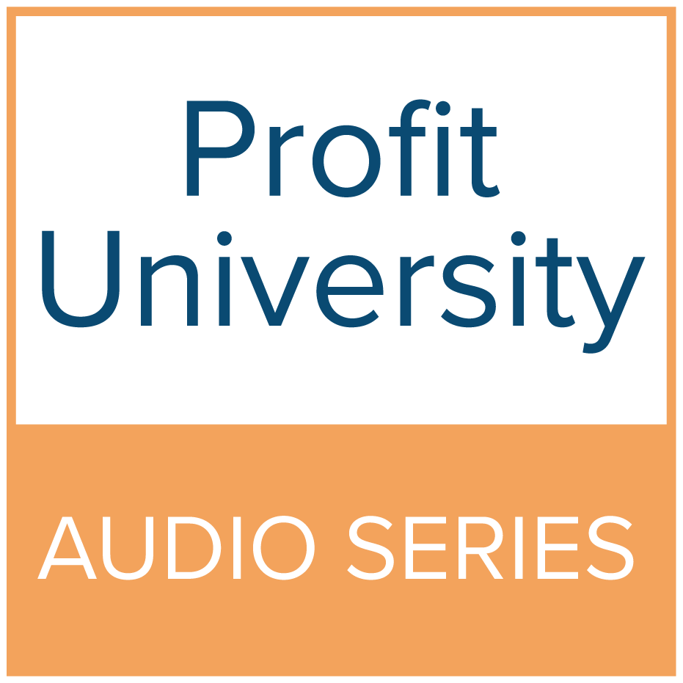
Short Summary for Website
August 2023

Title : Is a Podcast Right for Me?

Author : Carrie Vajko

Contact Information:

Carrie Vajko
Green Bay, WI 54311

Phone : 920-570-2309
E-mail : carrie@carrievajko.com
Website : https://carrievajko.com
Photo :

PDF :

Subject : Marketing Management

Short Summary:
- With the increase in popularity of podcasts, many business owners are now seeing the value of its ability to spread their expertise to their target demographic.
- Make sure that you have long-form content that YOU own, in order to ensure the safety of your product.
- Work out of a place of your own expertise, and use it as an opportunity to teach others.
- Long-form media like podcasts helps to form a trusting relationship with potential clients.
- Because podcasting is so new, there is still a booming and open market for it.
- Most people who start a podcast end up abandoning it. Consistency is key. Build the relationship with your viewers and potential clients by being consistent in your content and release dates.

“Is a Podcast Right for Me?” Resources

Audio Editing Software
- Reaper: https://www.reaper.fm/
- Adobe Premier Pro: https://www.adobe.com/
- Davinci Resolve: https://www.blackmagicdesign.com/products/davinciresolve
- Audacity: https://www.audacityteam.org/

Podcast Host Sites
- Buzzsprout: https://www.buzzsprout.com/
- Spotify for Podcasters*: https://podcasters.spotify.com/
- Libsyn: https://libsyn.com/
- Pod Bean: https://www.podbean.com/

*If you choose the unpaid option, you do not technically own any of your content. Spotify will reserve all rights to your recordings.

